Cypher Anxiety

Hey folks !! Today I have another challenge to solve named as Cypher Anxiety is an easy level file An image was leaked from a babies store. the manager is so annoyed because he needs to identify the image to fire charges against the responsible employee. the key is the md5 of the image

here is the link to download this file: -https://s3-eu-west-1.amazonaws.com/talentchallenges/Forensics/find+the+image.zip

Download file and unzip the file  
  
After Download file will unzip the file

\*must be found in file directory

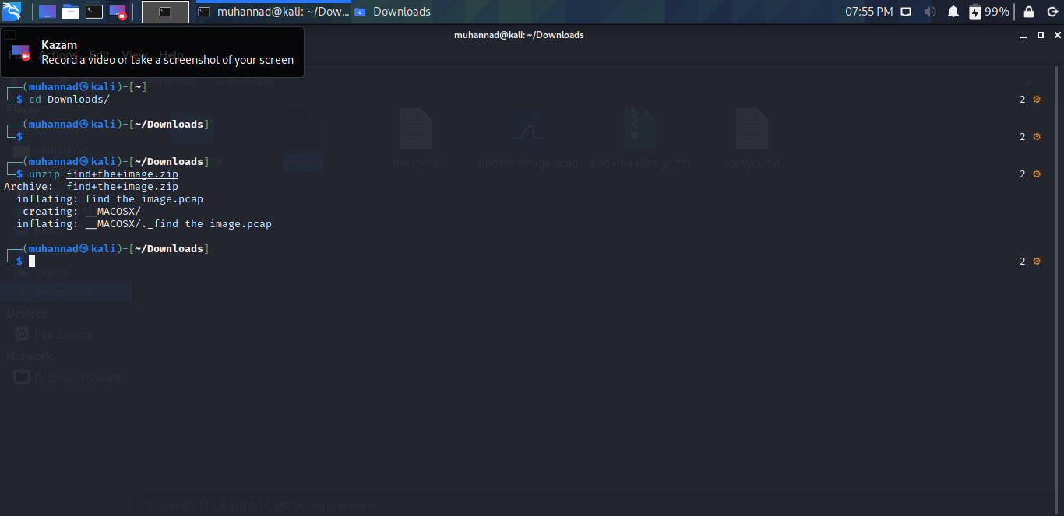

Open file With Wireshark  
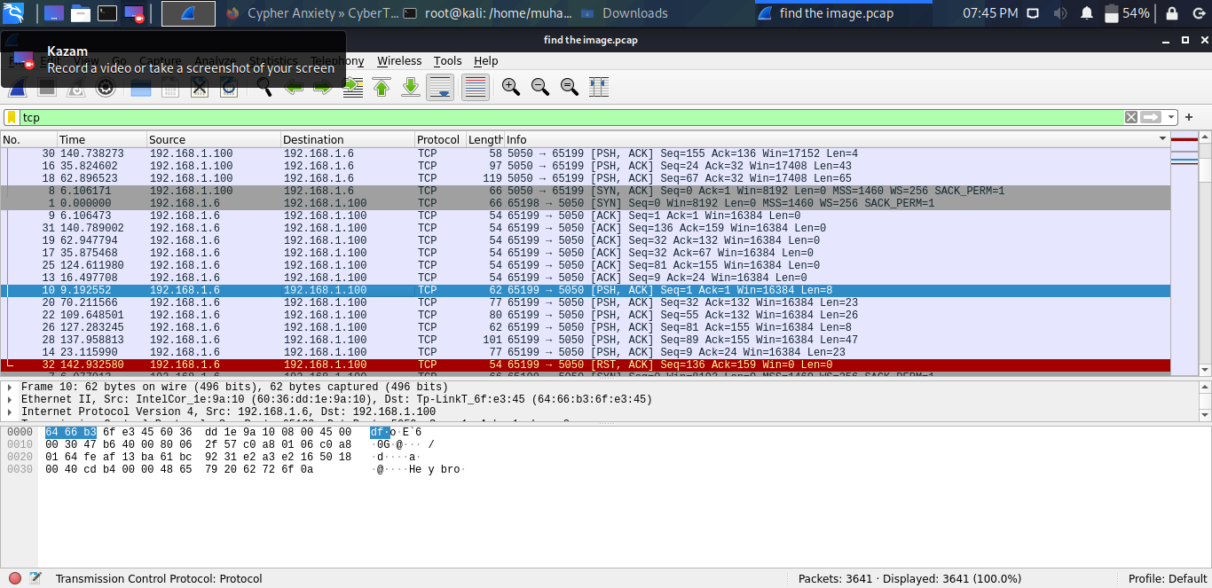  
  
  
there is a conversation in the captured packets let's read it a better way  
  
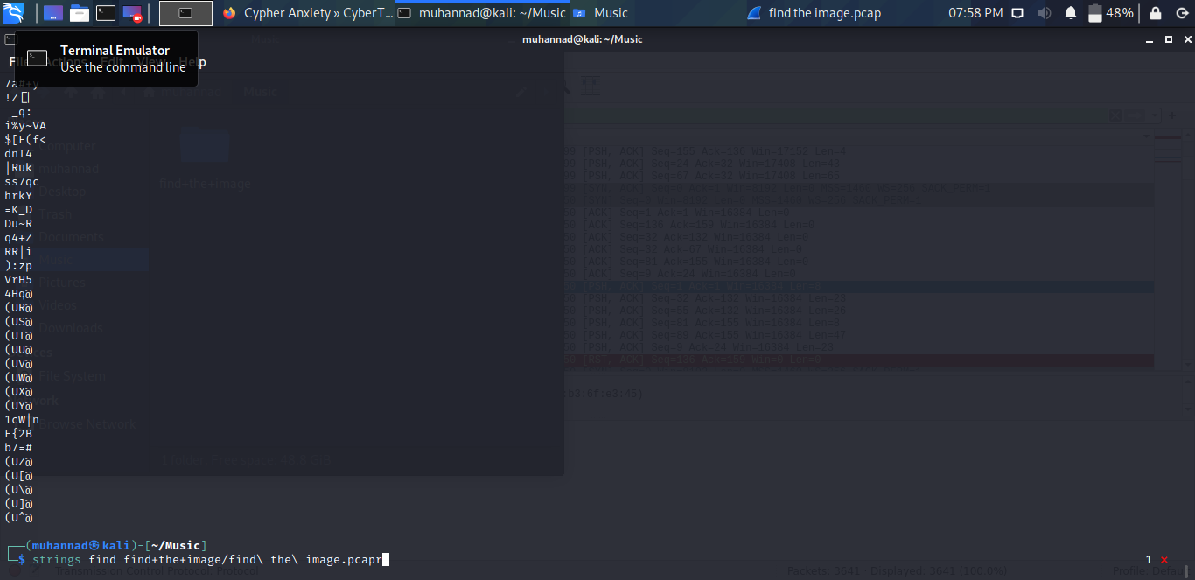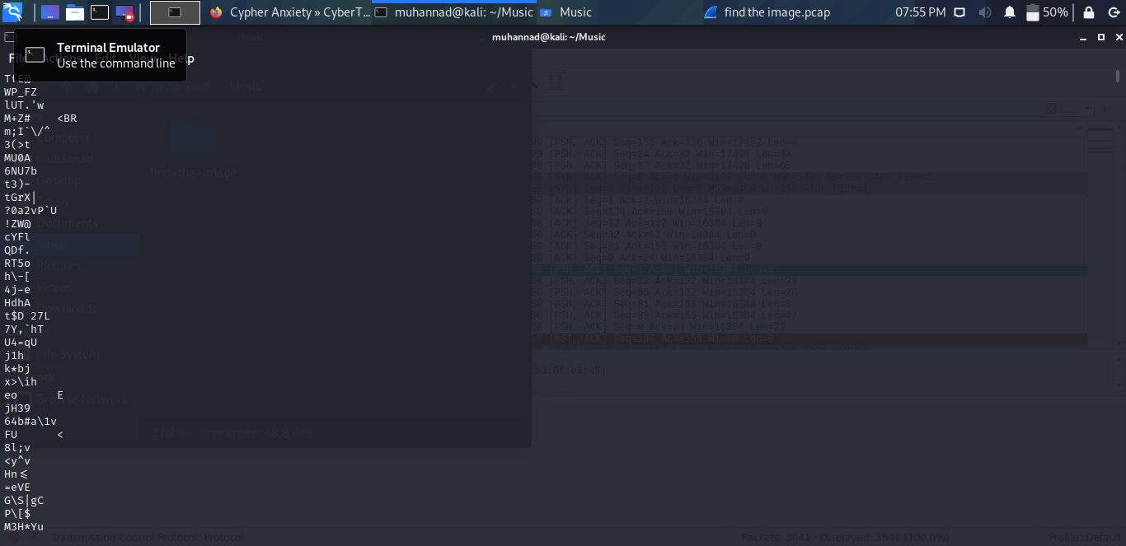

listen on 7070 and ill send you the file .  
  
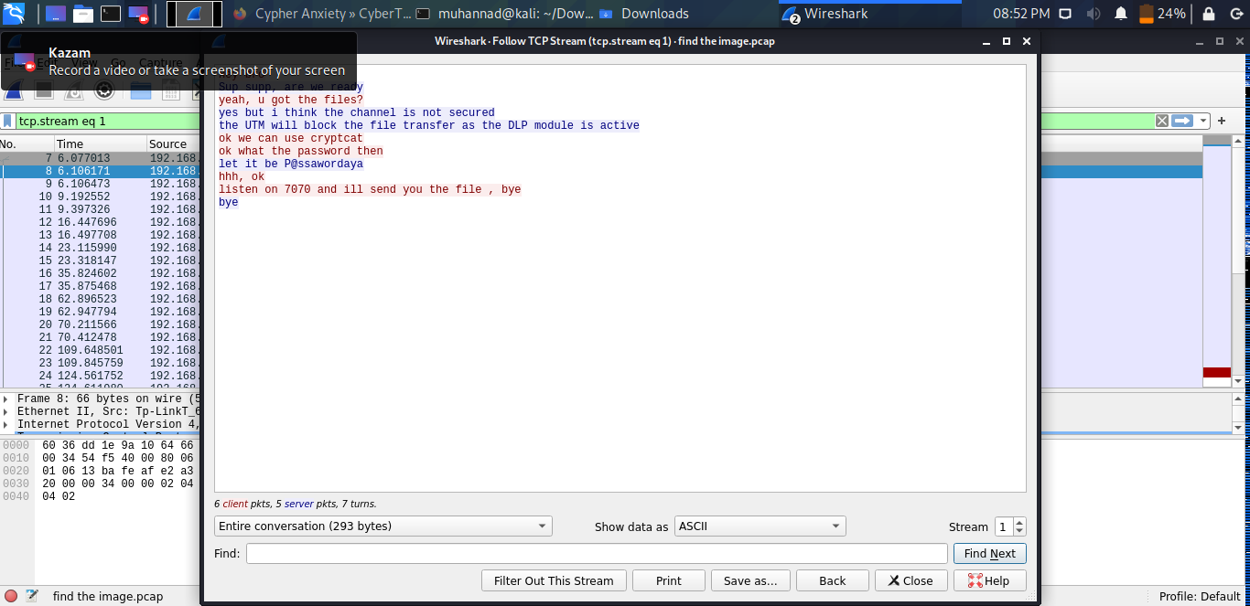  
  
lest dump all row traffic flowing in 7070 port and listen to the traffic.

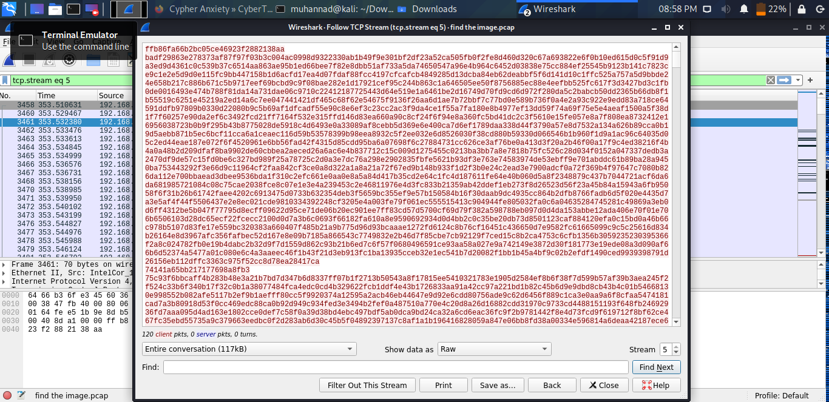  
  
we are using the password to listen from encrypted file  
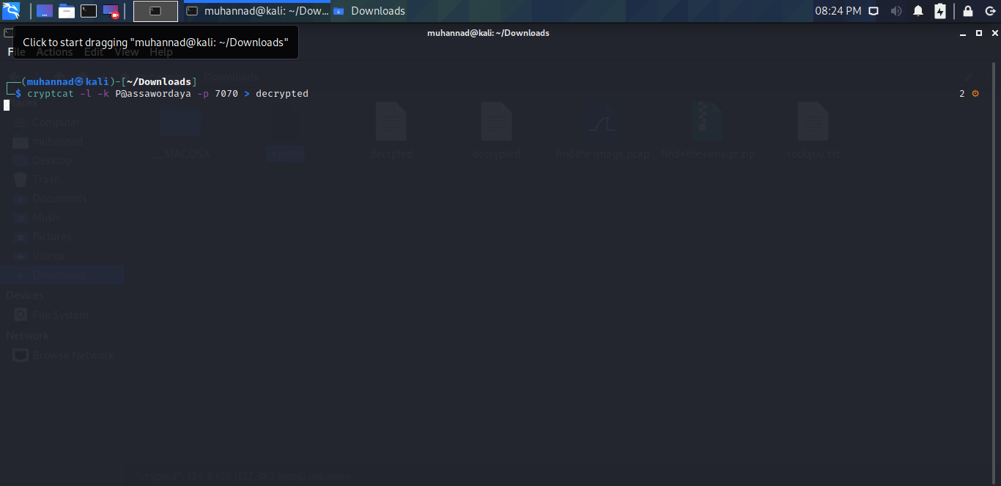

it worked and we got the file nothing in the file 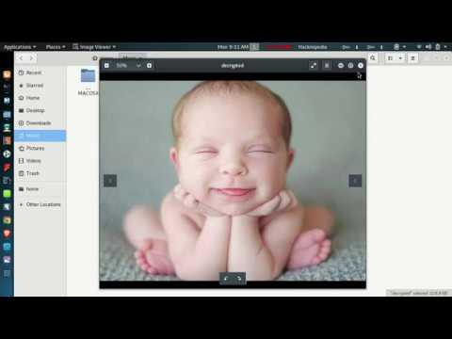

the flag is md5sum of file let's calculate it and submit

